Issue to WIP
Moving components into a work-in-progress warehouse
Fuse Manufacturing — user guide 03

Before you start

What this job is
Issue to WIP records components leaving a store and arriving in a work-in-progress warehouse, ready to be used in production. WIP stands for work in progress.
The stock is still yours and still counted. It has simply moved from the store to the factory floor. Nothing has been consumed — that happens when you record the production itself, against the works order.

When you need it, and when you do not
Use it when material is staged before a run: drawn from the store in the morning for a batch that will be mixed later in the day.
You do not need it if components go straight from the store into the mixer when you record production. In that case the works order takes them directly from the store and there is nothing to stage.
The advantage of staging is visibility. Anything sitting in a work-in-progress warehouse is material that has left the store but has not yet been made into anything, and that is worth being able to see.

What a warehouse means here
A warehouse in Fuse is any place stock can sit: stores, dispatch areas, consignment locations and work-in-progress areas on the factory floor. Every warehouse comes from Sage Intacct — you cannot create one in Fuse and you should not try.
Names follow a pattern: the site, then the area, then the company. For example, JHB Industria - Dispatch - LRC. The LRC at the end is Leader Rubber Company and appears on every warehouse.
The work-in-progress warehouses are named Fuse_WIP_Process1, Fuse_WIP_Process2 and so on. Your supervisor will tell you which one belongs to which part of the floor.

Two things that are always true
- You can only move stock that is actually in the store. Fuse will not let you issue 500 kg from a store holding 200 kg.
- Source and target must be different warehouses.

It is a transfer underneath
As far as stock is concerned this is an ordinary warehouse transfer, and it reaches Intacct as one. The only differences are that the destination is a work-in-progress warehouse, and that Fuse keeps these movements separate so you can see what is out on the floor.

Doing it

Step 1 — Open the screen
- On Fuse Home, click Issue to WIP.
A new Stock Entry opens with the type already set to Material Transfer for Manufacture. Leave that exactly as it is — it is what marks this as an issue to the floor rather than an ordinary move. If it says anything else, close the form and start again from the tile.
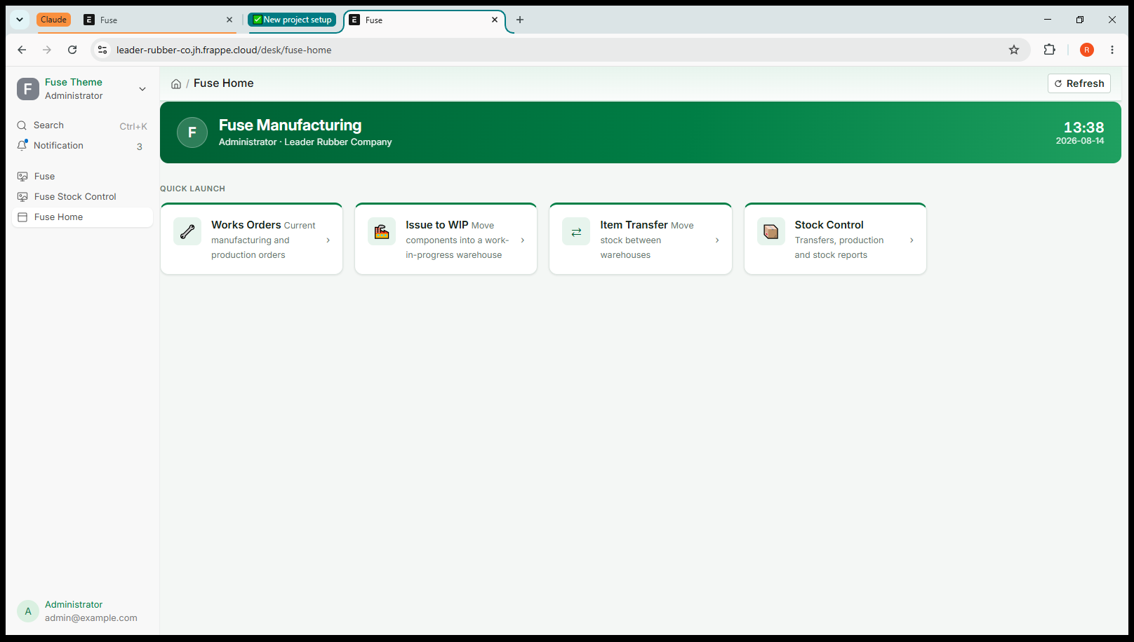
Screenshot 1 — A new Issue to WIP, with the type already filled in

Step 2 — The Work Order box
Near the top you will see a Work Order box. Filling it in is optional.
- Fill it in when the material is being drawn for one specific works order. The issue is then linked to that order and easy to trace.
- Leave it empty when you are simply stocking the floor for general use.
Either way the stock movement is identical. The link is for traceability, not for the movement itself.

Step 3 — Fill in the line
Scroll down to the section headed Items. There is a table with one empty row, numbered 1. Each row is one component. Click into the first box on the row to begin.
- Source Warehouse: Set Source Warehouse — the store the components are coming out of.
- Target Warehouse: Set Target Warehouse — the work-in-progress warehouse.
- Item Code: Type part of the code or part of the description and choose from the list.
- Qty: How much is going to the floor, in the item's own unit.

Always pick from the list
When you type into a warehouse or item box, a list appears underneath. Click the entry you want — do not type the name and move on. The search matches loosely, so typing “JHB Industria - Dis” will also offer Cape Town - Dispatch. If a box looks empty after you have typed in it, that is what happened: click into it and choose from the list.
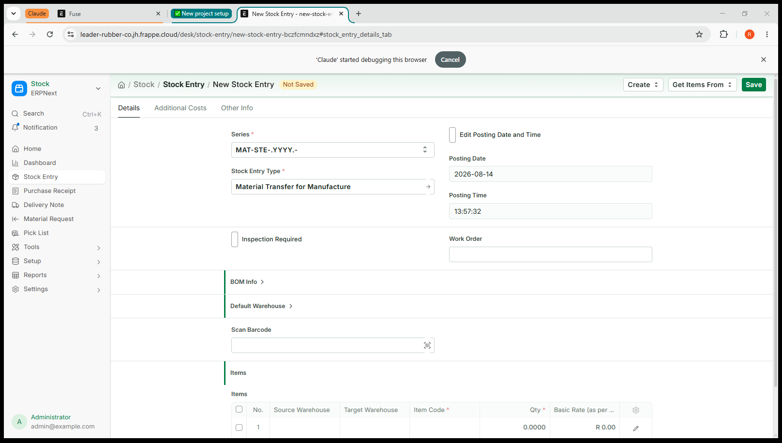
Screenshot 2 — A completed line: mixing store to Fuse_WIP_Process1, 25 kg of RMNR20
You will see a Basic Rate appear once you choose the item. That is what the stock is already worth. Leave it — you never price a movement.

Step 4 — Add the rest of the components
One issue can carry as many components as you like. If you are drawing eight materials for a batch, that is one document with eight rows, not eight documents.
- Click Add row underneath the table.
- Fill it in the same way.
- Repeat until everything going to the floor is listed.
To remove a row added by mistake, tick the box at the left of it and choose the delete option that appears.

Step 5 — Save, check, submit
- Click Save. The document is stored as a draft and given a number. No stock has moved.
- Read the lines against what is actually being carried to the floor: right store, right WIP warehouse, right quantities.
- Click Submit, and confirm.
Fuse sends the movement to Intacct, which records the components leaving the store and arriving in the work-in-progress warehouse. Only then is it recorded here.

Checking it worked
- Go to Fuse Home and click Stock Control.
- Under Reports, open Stock Balance.
- Filter to one of the components. The store should be lower and the work-in-progress warehouse higher, by the same amount.

What happens next
The components now sit in the work-in-progress warehouse. When you record production against the works order, take them from that warehouse rather than from the store — see the Works Orders guide.
Anything left over at the end of a run stays where it is. Either leave it for the next batch, or use Item Transfer to send it back to the store. It is not lost and it is not consumed; it is simply on the floor.

If something goes wrong

What you see | What it means and what to do
Source and destination are the same warehouse | Both boxes on a row point at the same place. Correct one of them.
Quantity must be positive | A quantity is zero, blank or negative. Enter a positive number.
Negative stock / not enough quantity | The store does not hold that much. Check Stock Balance, or check you have the right warehouse.
A warehouse box looks empty after typing | You typed a name but did not click an entry in the list. Click into the box and choose from the list.
Intacct rejected the request | Intacct would not accept it, and its reason follows. Nothing has been recorded anywhere. If you cannot fix it, send the message to your administrator.

Two rules that apply to everything in Fuse

Saving is not submitting
Saving stores a draft. A draft changes no stock at all, in Fuse or in Sage Intacct, and you can edit it, leave it, or delete it freely. Nothing has happened yet.
Submitting is the moment it becomes real. Fuse sends the movement to Intacct, and only once Intacct has accepted it does Fuse record it here. Read your work between the two.

Cancel, never delete
If you get something wrong after submitting, open the document and choose Cancel. Fuse reverses the movement in Intacct first, then cancels it here, so both systems return to where they were.
Do not delete, and do not try to correct a mistake by entering a second, opposite movement. Deleting would remove the record here while Intacct still holds the movement, and an opposite entry leaves two wrong movements in the history instead of none.

Why the two systems cannot disagree
Fuse and Sage Intacct hold the same stock. Fuse always sends the movement to Intacct first and waits for it to be accepted. If Intacct refuses, nothing is saved in either system and the reason appears on screen. That is why you never enter anything twice, and why nobody has to reconcile the two afterwards.

Jobs that belong in Intacct
Fuse will stop you doing these, with a message explaining why. Nothing is saved and nothing is broken — the job simply belongs in the other system.

If you try to | What happens
Receive goods from a supplier | Refused. Goods receipting is done in Intacct. Fuse shows what is on order so you can plan, but the receipt is recorded there.
Adjust stock up or down | Refused. On-hand corrections are made through a Cycle Count in Intacct.
Change an item, warehouse or supplier | Read-only here. These come from Intacct, and a change made in Fuse would be overwritten at the next sync.

Practise it
- In Stock Control, open Stock Balance and find a component with stock in a mixing store. Write the figure down.
- Issue a small quantity of it to a work-in-progress warehouse.
- Check Stock Balance again — the store down, the WIP warehouse up, by the same amount.
- Cancel the issue, and check the figures return to what you first wrote down.

Quick reference
Fuse Home → Issue to WIP → source store, WIP warehouse, item, quantity → Save → check → Submit.

Question | Answer
Is the stock consumed? | No. It has only moved. Consumption happens at production.
Must I link a works order? | No, it is optional.
Can I issue several components at once? | Yes. One row each.
Do I set a price? | No. Fuse uses what the stock is already worth.
What if too much was issued? | Leave it for the next batch, or transfer it back.
Does saving move stock? | No. Only submitting does.
How do I undo it? | Open it and Cancel. Never delete.

Where this goes
Fuse and Sage Intacct hold the same stock. Anything you submit here is sent to Intacct immediately, and Fuse only records it once Intacct has accepted it. If Intacct refuses, nothing is saved in either system and you will see the reason on screen.

